Dr. Virendra Swarup Education Centre
(Affiliated to C.B.S.E., Delhi Reg. No. - 2130700
884-A, B-Block, Panki, Kanpur-208020 Ph. : 0512-2261313, 2261314
Visit us at :www.vsecpanki.co.in , E-mail : vsec_panki@rediffmail.com
S C H O L A R’ S T R A N S F E R C E R T I F I C A T E
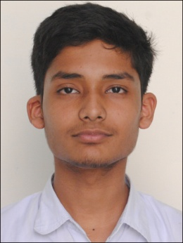

T.C. No. : 3 Scholar No. 1256

This is to certify that UJJWAL MATHUR Son of MR.SOMENDRA MATHUR
was admitted into this school on April 2005 in Class JKG on a Transfer
Certificate from N/A and left on 31.03.2019 with a good character.
He has passed class XII of the C.B.S.E. Board. The school year being
from April 2018 to March 2019.
All sums due to this school on his account have been remitted.
His date of birth, according to our Admission Register is 7/28/2001
(MM/DD/YYYY)

Date 02.05.2019

………………………… …………………….
PREPARED BY PRINCIPAL

